Welcome to the
Parish Church of Holy Trinity, Blythburgh,
in the Sole Bay Team of Churches
Sunday 4 August 2019 Seventh after Trinity
Choral Evensong

Introit O taste and see Ralph Vaughan Williams 1872-1958
O taste and see how gracious the Lord is: blest is the man that trusteth in him.
Words from Psalm 34 v 8
Hymn All creatures of our God and King 263
Confession and Absolution
The Lord’s Prayer (All)
Responses Herbert Sumsion 1899-1995
Psalm Psalm 49 vv1-12
First Reading Ecclesiastes 1.2,12-14; 2.18-23
Hymn Be thou my vision, O Lord of my heart 339
Magnificat in F minor by Alan Gray 1855-1935
Second Reading Luke 12.13-21
Nunc dimittis in F minor by Alan Gray 1855-1935
Creed
Responses Herbert Sumsion 1899-1995

The Collect of the Day
Lord of all power and might, the author and giver of all good things: graft in our hearts the love of your name, increase in us true religion, nourish us with all goodness, and of your great mercy keep us in the same; through Jesus Christ your Son our Lord, who is alive and reigns with you, in the unity of the Holy Spirit, one God, now and for ever.
The Collect for Peace
The Collect for aid against all perils
Anthem Glorious and powerful God
Charles Villiers Stanford 1852-1924
Glorious and pow'rful God, we understand thy dwelling is on High above the starry sky.
Thou dwell'st not in stone temples made with hand, but in the flesh hearts of the sons of men to dwell is thy delight, near hand, tho' out of sight.
We give of thine own hand; thy acceptation is very life and blood to all actions good.
Whenever here or hence our supplication from pure and with unfeigned hearts to thee ascends, be present with thy grace, show us thy loving face.
Oh! down on us full show'rs of mercy send; let thy love's burning beams dry up all our sin's streams.
Arise O Lord and come into thy rest, both now and evermore. Thy name be blest, Founder and Foundation of endless habitation.

Sermon
Prayers
Hymn Now thank we all our God 413
(The offering will be taken up during this hymn)
Blessing

NOTICES
Our music is led by The Blythburgh Singers, who enjoy singing church music and who meet on the first Sunday of the month to sing Choral Evensong here. For more details, please contact Helen Hudson on 01502 511546 or flautodolce@corystes.plus.com.
As you can see, this weekend the church is hosting The Blythburgh Summer Exhibition. Subtitled “a celebration of a creative village”, this is a display of creative work by resident talent: from paintings to pots, from sculpture to sewing, and much beside. Do take time to browse before and after the service.
Our hugely popular service for the Blessing of Animals will take place on Sunday 18 August at 11am. All creatures great and small welcome.
Inspired by Becker The painter Harry Becker (1865-1928) settled in Suffolk in 1913 after a relatively successful artistic career in London. He shunned the commercial art world in favour of drawing and painting (outdoors) the rural landscapes and the people who lived and worked there. His work continues to engage artists to this day, generating an annual exhibition called Inspired by Becker, which features many East Anglian artists producing work in tribute to him. This year the show will be held in Holy Trinity Blythburgh from 22-26 August, 10.30am to 5.30pm daily. There will be a preview open to all on Wednesday 21 Aug at 6pm and on Friday 23 August at 6.30pm Richard Hawking will talk about his book ‘At the Field’s Edge: Adrian Bell and the English Countryside’.
BEACH MISSION 29TH JULY - 9TH AUGUST
Please encourage people of all ages to go along to the Beach Mission which has morning, afternoon and evening activities. Events are free and open to all. For more information go to the Beach Mission website - Southwoldbeachmission.com
MONDAY 5 AUGUST - St Andrews, Sotherton is holding a cake stall from 9am outside the old Lloyds Bank in the market place Southwold.
A JAZZ EVENING IN MEMORY OF SIDI SCOTT
Saturday 14 September, St Peter & St Paul, Wangford, 7.30pm
In memory of Sidi, Martin Smith (Sidi’s son in law) and his Jazz Band, the Jazz Goats will be performing in St Peter & St Paul, Wangford on Saturday 14 September. Tickets including a licensed bar are £10. All funds raised will go towards the Church Restoration Fund. Tickets are available now through Southwold Arts Centre 01502 722572 or www.ticketsource.co.uk or from Revd Alan.
REGULAR SERVICES
1st Sunday 11.15am Holy Communion (Common Worship)
of the month Joint service at St Andrew’s, Walberswick
6pm Choral Evensong (BCP)
led by The Blythburgh Singers directed by Ellis Bell with organist Jonathan Palman
2nd Sunday 11.15am Holy Communion (Common Worship)
Joint service at Holy Trinity, Blythburgh
3rd Sunday 9.30am Morning Prayer (Common Worship)
4th Sunday 9.30am Holy Communion (BCP said)
5th Sunday 11am Team Service – see noticeboard for venue
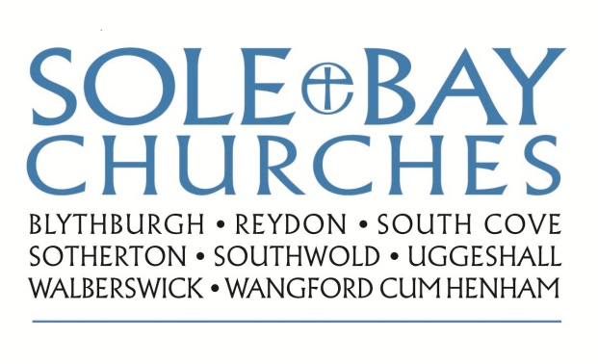
Team Rector: Revd Simon Pitcher
01502 725424 revsimon63@gmail.com
Churchwarden: Mrs Meryl Doney
01502 478229 meryldoney@me.com

