Welcome to the
Parish Church of Holy Trinity, Blythburgh,
in the Sole Bay Team of Churches
Sunday 6 October 2019 Sixteenth after Trinity
Choral Evensong

Introit Ubi Caritas Francis Pott b1957
Wherever charity and love reside, there God is found. He has gathered us into one love of Christ. Wherefore let us rejoice and be glad; let us fear and love the living God, and with a true heart let us esteem ourselves highly in these things. Amen.
Words from the composer's own translation of ancient manuscript text.
Hymn Light of the minds that know him 400
Confession and Absolution
The Lord’s Prayer (All)
Responses Bernard Rose 1916-1996
Psalm Psalm 37 vv1-9
First Reading Habakkuk 1.1-4; 2.1-4
Hymn O thou who camest from above 431
Magnificat in D by Herbert Brewer 1865-1928
Second Reading Luke 17.5-10
Nunc dimittis in D by Herbert Brewer 1865-1928
Creed
Responses Bernard Rose 1916-1996

The Collect of the Day
O Lord, we beseech you mercifully to hear the prayers of your people who call upon you; and grant that they may both perceive and know what things they ought to do, and also may have grace and power faithfully to fulfil them; through Jesus Christ your Son our Lord, who is alive and reigns with you, in the unity of the Holy Spirit, one God, now and for ever.
The Collect for Peace
The Collect for aid against all perils
Anthem Evening Hymn Henry Balfour Gardiner 1877-1950
Te lucis ante terminum,  rerum Creator, poscimus,  ut solita clementia,  sis praesul ad custodiam.  Procul recedant somnia,  et noctium phantasmata:  hostemque nostrum comprime,  ne polluantur corpora.  Praesta, Pater omnipotens,  per Iesum Christum Dominum,  qui tecum in perpetuum  regnat cum Sancto Spiritu.  Amen. | To thee before the close of day,  Creator of the world, we pray  That, with thy wonted favour, thou  Wouldst be our guard and keeper now.  From all ill dreams defend our sight,  From fears and terrors of the night;  Withhold from us our ghostly foe,  That spot of sin we may not know.  O Father, that we ask be done,  Through Jesus Christ, thine only Son,  Who, with the Holy Ghost and thee,  Doth live and reign eternally.  Amen.
Words from the Office Hymn for Compline
Sermon
Prayers
Hymn O Jesus, I have promised 420
(The offering will be taken up during this hymn)
Blessing

NOTICES
Our music is led by The Blythburgh Singers, who enjoy singing church music and who meet on the first Sunday of the month to sing Choral Evensong here. For more details, please contact Helen Hudson on 01502 511546 or flautodolce@corystes.plus.com.
October sees the annual William Alwyn Music Festival, honouring the composer William Alwyn who once lived in Blythburgh. At Holy Trinity, Blythburgh, on Friday 11 October 2019 at 10:30am, the Gildas Quartet and Jack McNeill will be performing: Herbert Howells: Rhapsodic Quintet op.31; Alwyn: Novelette, for string quartet; Lloyd Moore: Airs and Arabesques, for solo clarinet; Mozart: Clarinet Quintet in A major, K.581. Ticket price £12 unreserved. Details of all performances at: www.alwynmusicfestival.co.uk.
Friday 25 October from 10.30am, til noon - join the gathered throng at our monthly café and Mini-market.
Remembrance in Blythburgh – our joint Service of Remembrance with St Andrew’s, Walberswick will take place this year at St Andrew’s, beginning at 10.50am.
Advance notice that our annual Christmas Market will take place in the church on Saturday 30 November from noon to 4pm. Over 30 stalls selling local crafts, food and drink, Christmas cards and decorations, plus home-made soups, mulled wine, mince-pies and cakes to fortify you for your Christmas shopping! This will be followed the next day by an Advent Carol Service led by the Blythburgh Singers, beginning at 6pm. The Singers will also be leading a Service of Lessons and Carols for Christmas on Sunday 22 December at 4pm.
REGULAR SERVICES
1st Sunday 11.15am Holy Communion (Common Worship)
of the month Joint service at St Andrew’s, Walberswick
6pm Choral Evensong (BCP)
led by The Blythburgh Singers directed by Ellis Bell with organist Jonathan Palman
2nd Sunday 11.15am Holy Communion (Common Worship)
Joint service at Holy Trinity, Blythburgh
3rd Sunday 9.30am Morning Prayer (Common Worship)
4th Sunday 9.30am Holy Communion (BCP said)
5th Sunday 11am Team Service – see noticeboard for venue
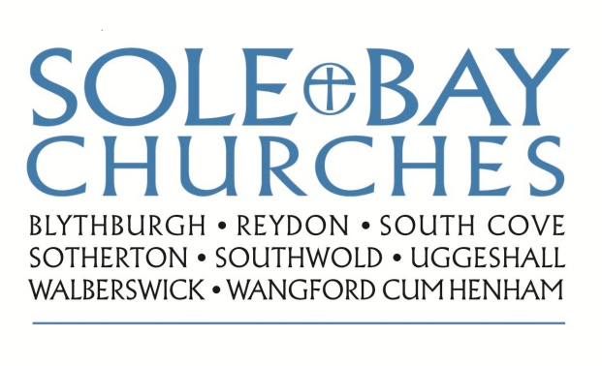
Team Rector: Revd Simon Pitcher
01502 725424 revsimon63@gmail.com
Churchwarden: Mrs Meryl Doney
01502 478229 meryldoney@me.com

