Welcome to the
Parish Church of Holy Trinity, Blythburgh,
in the Sole Bay Team of Churches
Sunday 7 April 2019 Fifth of Lent
Choral Evensong

Introit Drop, drop, slow tears Orlando Gibbons 1583-1625
Drop, drop, slow tears, and bathe those beauteous feet
Which brought from heav'n the news and Prince of peace:
Cease not, wet eyes, his mercies to entreat;
To cry for vengeance sin doth never cease:
In your deep floods drown all my faults and fears;
Nor let his eye see sin, but through my tears.
Words by Phineas Fletcher 1582-1650
Hymn Jesu, the very thought of thee 385
Confession and Absolution
The Lord’s Prayer (All)
Responses Thomas Tomkins 1572-1656
Psalm Psalm 126
First Reading Isaiah 43.16-21
Hymn Praise to the Holiest in the height 439
Magnificat in A by Herbert Sumsion 1899-1995
Second Reading John 12.1-8
Nunc dimittis in A by Herbert Sumsion 1899-1995
Creed
Responses Thomas Tomkins 1572-1656

The Collect of the Day
Most merciful God, who by the death and resurrection of your Son Jesus Christ delivered and saved the world: grant that by faith in him who suffered on the cross we may triumph in the power of his victory; through Jesus Christ your son our Lord, who is alive and reigns with you, in the unity of the Holy Spirit, one God, now and for ever.
The Collect for Peace
The Collect for aid against all perils
Anthem When David heard Thomas Tomkins 1572-1656
When David heard that Absolon was slain, he went up to his chamber over the gate, and wept: and thus he said, “O my son Absolon, would God that I had died for thee, O Absolon my son, my son”.
Words from 2 Samuel 18.33
Sermon
Prayers
Hymn Ah, holy Jesu 62
(The offering will be taken up during this hymn)
Blessing

NOTICES
Our music is led by The Blythburgh Singers, who enjoy singing church music and who meet on the first Sunday of the month to sing Choral Evensong here. For more details, please contact Helen Hudson on 01502 511546 or flautodolce@corystes.plus.com.

Sunday 5 May at 6pm: Instead of Choral Evensong, the Blythburgh Singers, together with an ensemble from Norwich Baroque, will be leading a sung Holy Communion based on Schubert’s Mass No 2 in G major, presided by the Revd Malcolm Doney.
Our Annual Parochial Church Meeting, will take place on Thursday 11 April, 7pm in the Village Hall. Everyone on the (new) Electoral Roll will have received an invitation and a copy of our Annual Report and Accounts. We are still seeking a second Churchwarden, and we will also be looking to elect one member to the PCC. Nomination forms are available at the back of the church.
Southwold Lent Lectures 2019 – The Last Enemy
TONIGHT Care for the Dying and the Bereaved
The Rev Sister Sharon Connell, Chaplain and Spiritual Care Co-ordinator, St Nicholas Hospice, Bury St Edmunds
14 April The Last Enemy Who Will Be Destroyed is Death
The Rt Revd Dr Mike Harrison, Bishop of Dunwich
All the lectures are at 6.00pm in the United Reformed Church, High Street, Southwold.
Lectures are available to listen online southwoldlectures.org
EASTER AT HOLY TRINITY
Palm Sunday 14 April 11.15am Holy Communion (Common Worship)
Maundy Thursday 18 April 7.30pm Holy Communion and Foot washing
Good Friday 19 April 5pm Easter Garden activity for children, followed by Easter egg hunt
Easter Day 21 April 11am Eucharist
Saturday 27 April at 6pm in Holy Trinity – the Bristol Chamber Choir, directed by Gordon Pullin (well known to many of us as a former Director of the Blythburgh Singers) and joined by Yalda Davis (’cello), will be presenting a concert of music by Wilbye, Kirbye, Bennet, Britten, Pearsall and Bach. Free entry, with a retiring collection for church funds.
The Friends of Holy Trinity Blythburgh will be holding their Open Day on the afternoon of Saturday 18 May at 2.30pm. The speaker this year will be Canon Roy Tricker. All are welcome.
REGULAR SERVICES
1st Sunday 11.15am Holy Communion (Common Worship)
of the month Joint service at St Andrew’s, Walberswick
6pm Choral Evensong (BCP)
led by The Blythburgh Singers directed by Ellis Bell with organist Jonathan Palman
2nd Sunday 11.15am Holy Communion (Common Worship)
Joint service at Holy Trinity, Blythburgh
3rd Sunday 9.30am Morning Prayer (Common Worship)
4th Sunday 9.30am Holy Communion (BCP said)
5th Sunday 11am Team Service – see noticeboard for venue
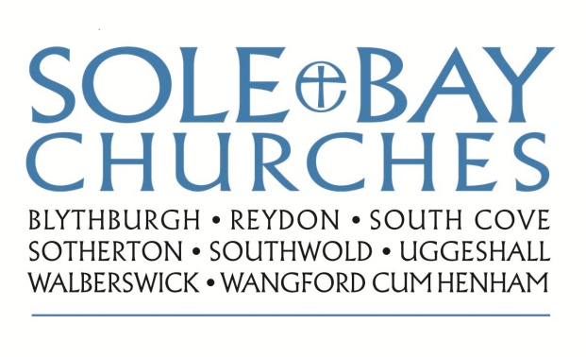
Team Rector: Revd Simon Pitcher
01502 725424 revsimon63@gmail.com
Churchwarden: Mrs Meryl Doney
01502 478229 meryldoney@me.com

