Welcome to the
Parish Church of Holy Trinity, Blythburgh,
in the Sole Bay Team of Churches
Sunday 1 September 2019 Eleventh after Trinity
Choral Evensong

Introit Blest are the pure in heart Henry Walford Davies 1869-1941
Blest are the pure in heart, for they shall see our God; the secret of the Lord is theirs, their soul is Christ's abode.
Still to the lowly soul he doth himself impart, and for his dwelling and his throne chooseth the pure in heart.
Words by John Keble 1792-1866
Hymn All my hope on God is founded 333
Confession and Absolution
The Lord’s Prayer (All)
Responses Peter Aston 1938-2013
Psalm Psalm 112
First Reading Proverbs 25.6-7
Hymn Just as I am, without one plea 294
Magnificat in F by Charles Wood 1866-1926
Second Reading Luke 14.1,7-14
Nunc dimittis in F by Charles Wood 1866-1926
Creed
Responses Peter Aston 1938-2013

The Collect of the Day
O God, you declare your almighty power most chiefly in showing mercy and pity: mercifully grant to us such a measure of your grace, that we, running the way of your commandments, may receive your gracious promises, and be made partakers of your heavenly treasure; through Jesus Christ your Son our Lord, who is alive and reigns with you, in the unity of the Holy Spirit, one God, now and for ever.
The Collect for Peace
The Collect for aid against all perils
Anthem Love bade me welcome David Hurd b1950
Love bade me welcome: yet my soul drew back, guiltie of dust and sinne.
But quick-ey'd Love observing me grow slack from my first entrance in,
drew nearer to me, sweetly questioning, if I lacked anything.
A guest, I answer'd, worthy to be here: Love said, You shall be he.
I, the unkinde, ungratefull? Ah, my deare, I cannot look on thee.
Love took my hand and smiling did reply, who made the eyes but I?
Truth, Lord but I have marr'd them: let my shame go where it doth deserve.
And know you not, sayes Love, who bore the blame? My deare, then I will serve.
You must sit down, sayes Love, and taste my meat: so I did sit and eat.
Words by George Herbert 1593-1633
Sermon
Prayers
Hymn How shall I sing that majesty 373
(The offering will be taken up during this hymn)
Blessing
NOTICES
Our music is led by The Blythburgh Singers, who enjoy singing church music and who meet on the first Sunday of the month to sing Choral Evensong here. For more details, please contact Helen Hudson on 01502 511546 or flautodolce@corystes.plus.com.
Sunday 8 September at 11.15am is our Harvest Festival service, followed by a delicious seasonal lunch. If you would like to join us for our harvest lunch, please email Meryl Doney (meryldoney@me.com) to help us in our catering planning.
Saturday 14 September sees the annual Suffolk Churches Ride and Stride, from 9am to 5pm – when people on two wheels or two feet, tour Suffolk churches in aid of the Suffolk Historic Churches Trust. Volunteers will be on hand at Holy Trinity to provide a welcome to all visitors. If you are interested in spending an hour or so welcoming our visitors, or in riding/walking to raise funds specifically for Holy Trinity, please contact Paul Simmons who has all the details.
Sunday 15 September at 6pm in Holy Trinity: ANAM CORA present “The Fruits of the Year”, a sung meditation. Anam Cora’s pilgrimage through the Cycle of the Year reaches the “Season of mists and mellow fruitfulness”, and these five singers offer a sung meditation tuned to autumn’s abundance. They will weave sound, song, silence and poetry around the inspiring angel-roofed spaces of this “Cathedral of the Marshes”. Come and join them! No booking required. Donations invited.
For more information on this event contact Caroline Weatherby 01728 664112
For more information on Anam Cora visit: www.marybenefiel.com/anam-cora/
A Jazz Evening in memory of Sidi Scott - Saturday 14 September, St Peter & St Paul, Wangford at 7.30pm by Martin Smith (Sidi’s son in law) and his Jazz Band, the Jazz Goats. Tickets, including a licensed bar, are £10. All funds raised will go towards the Church Restoration Fund. Tickets available through Southwold Arts Centre 01502 722572 www.ticketsource.co.uk or Revd Alan Perry.
Sunday 29 September (St Michael & All Angels): Team Service at St Margaret’s, Reydon at 11.15am Guest speaker will be Charles Storer (son of Jack) who will talk about his work for the charity Hope and Aid Direct, which works to provide support for the world’s refugees.
Sunday 29 September – Deanery Evensong to celebrate St Michael & all Angels at St Andrew’s Church, Wissett, 3pm. Guest preacher Revd Jeanette Gosney, acting Archdeacon of Suffolk.

REGULAR SERVICES
1st Sunday 11.15am Holy Communion (Common Worship)
of the month Joint service at St Andrew’s, Walberswick
6pm Choral Evensong (BCP)
led by The Blythburgh Singers directed by Ellis Bell with organist Jonathan Palman
2nd Sunday 11.15am Holy Communion (Common Worship)
Joint service at Holy Trinity, Blythburgh
3rd Sunday 9.30am Morning Prayer (Common Worship)
4th Sunday 9.30am Holy Communion (BCP said)
5th Sunday 11am Team Service – see noticeboard for venue
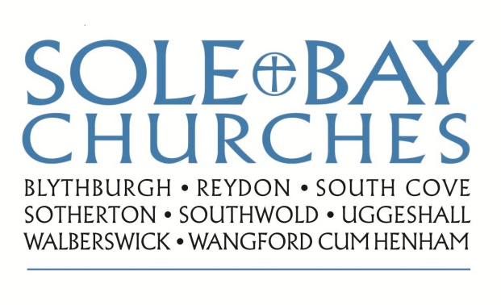
Team Rector: Revd Simon Pitcher
01502 725424 revsimon63@gmail.com
Churchwarden: Mrs Meryl Doney
01502 478229 meryldoney@me.com

